**Milestone 2 - Planning and Design Document**

1) List the Resources you need to complete your project (the number of resources required depends on your project). This includes equipment, software, assets, etc… (1 mark)

1. Data Modeller.
2. Visio.
3. Photoshop.
4. Microsoft Project.
5. Stack overflow.
6. W3Schools.
7. Images for the gallery.
8. YouTube tutorials for certain features.
9. Java.
10. XAMP.

2) List 2 topics/aspects you need to research or practice more in order to have enough skills to complete your project. (1 mark)

1. Database connection using XAMP.
2. Sending receipt as an email from Java.

3) List and explain 1 risk that can happen during the process of carrying out your project, and what you plan to do in case it actually happens. (1 mark)

The corruption and loss of data related to the project is a risk that can happen during the development. This can be prevented by saving frequent backups and logs on several devices and online services such as OneDrive.

4) Mention an existing system the aims of which are similar to yours. Explain some of the most important and/or interesting features it has. (2 marks).

Maltco lotteries is a similar website to the one that I have constructed. Some important features that it has are: An advanced random number generator which several factors are taken into consideration such as the type of lotto game ex. Prima or Terno, the number of lotto balls that can be drawn, and the filter ex. If the most frequent number or the least frequent numbers should be displayed. Another feature which is interesting is that it has a video page that contains the latest draw of the week and it also the video number and the date. Another feature that is interesting and important is that there is a mini calendar that display the days and the days that numbers are drawn are highlighted and can be selected to display information about the lotto numbers that were drawn in that day.

**The Number Generator**

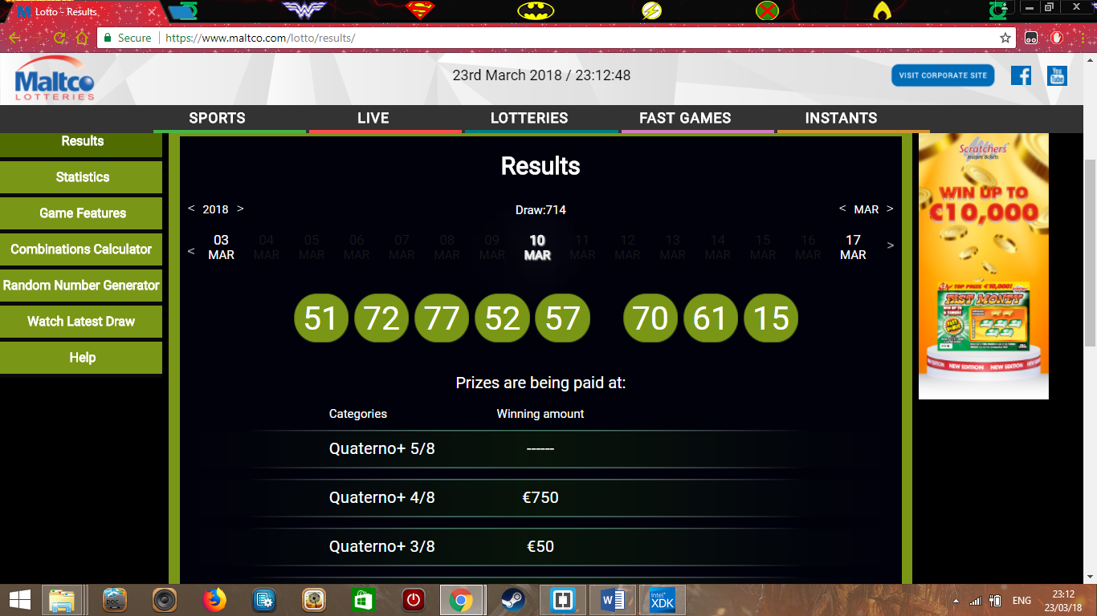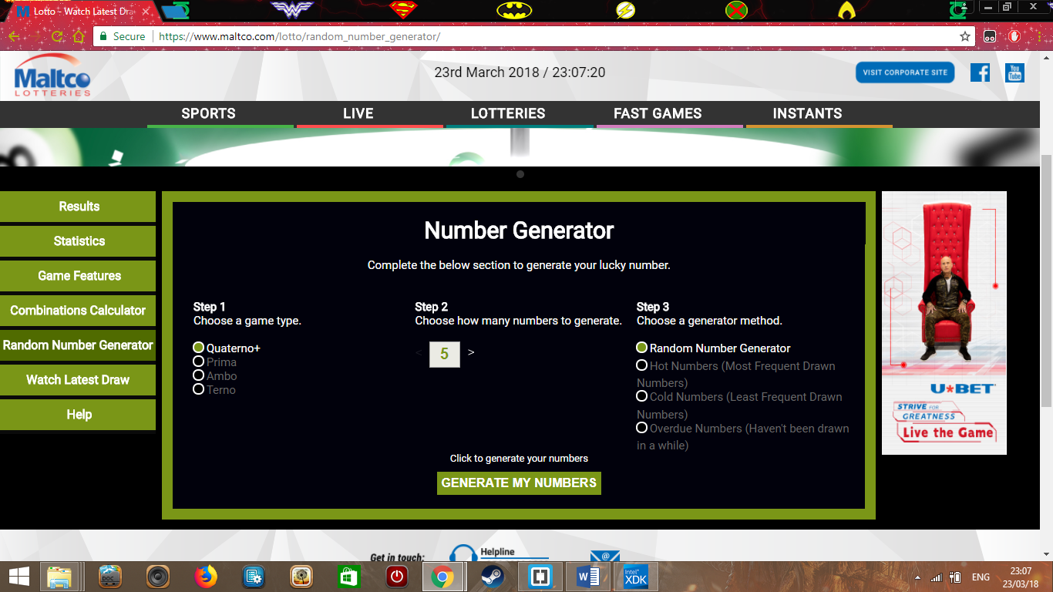

**The Calendar**

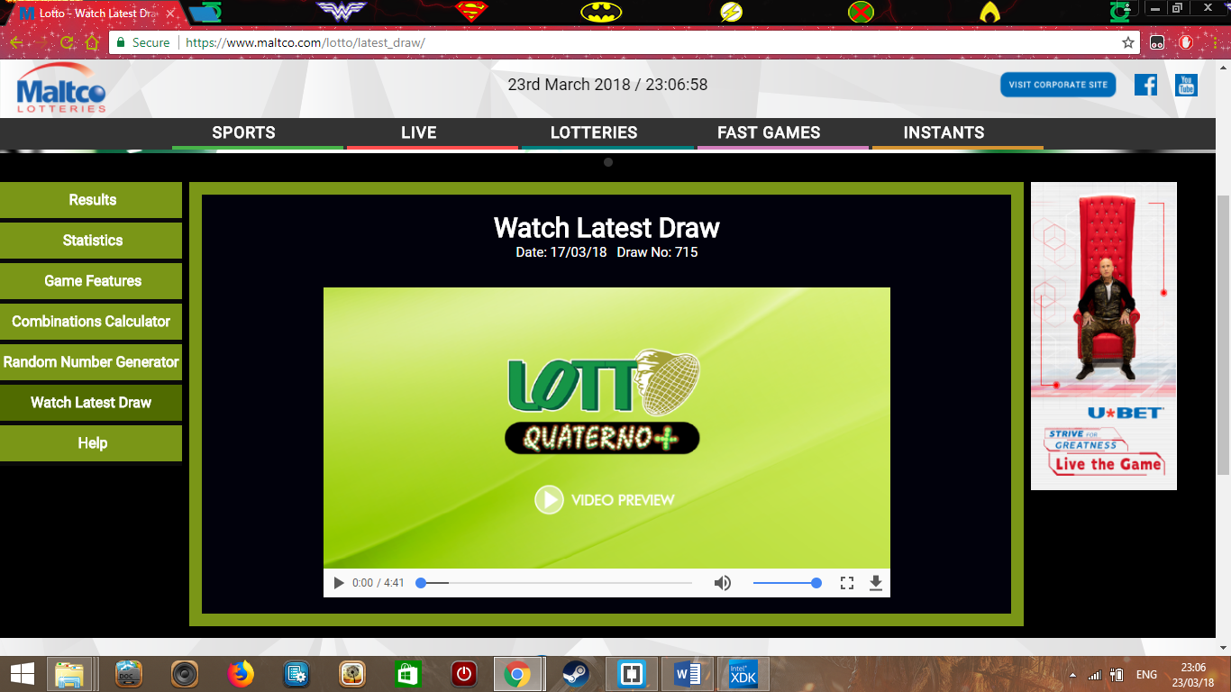**The Video Page**

5) In this section you will be planning your testing strategy. a) Plan and explain the testing strategy for your web application. Keep in mind the following points:

• What testing methodology and levels(unit testing when you create and test immediately) of testing will you be using throughout development and after development of your web application? (2.5 marks)

One methodology is that of compatibility, this is because I will make sure that the website will be compatible on different mobile and tablet devices. The levels of testing will be unit and integration testing, this is because I will first test each component separately and then I will integrate them together so that they are one finished product.

• What data will you use as part of your testing? (1 marks) (valid invalid)

The data I will use for my testing will be the website interface which is a valid test data. I will also enter extreme values for screen sizes and see if they work (Extreme, Valid, invalid).

b) Plan and explain the testing strategy for your desktop/mobile application. Keep in mind the following points:

• What testing methodology and levels of testing will you be using throughout development and after development of your desktop/mobile application? (2.5 marks)

One methodology is that of performance, this is because I will make sure that the application will work well. The levels of testing will be system, this is because I will test the entire system from end to end functionality. Moreover, this will result in making sure the overall output is advanced enough and works as intended.

**• What data will you use as part of your testing? (1 mark)**

**The data that will be part of my testing will be the input that will be used in the methods and all the processes that are going through the application. This will make sure that all the data is correctly being entered and processed correctly in the application. (**Extreme, Valid, invalid)

6) Divide the work that needs to be done into smaller tasks. Do not forget to include tasks which are not explicitly part of the system (such as testing and documentation). You can start from the next milestone after this one, i.e. Design/Modelling. (3 marks)

1. **Implement Home Page of the website.**
2. **Research about unknown features of the desktop application.**
3. **Research about unknown features of the website.**
4. **Create the logo.**
5. **Implement a fully working contact us page.**
6. **Design the flowcharts for three interactions.**
7. **Make the website look attractive.**
8. **Implement the code for the desktop application.**
9. **Implement the interface for the desktop application.**
10. **Implement the video page.**
11. **Implement the FAQ page.**
12. **Implement working navbar**
13. **Implement Responsiveness.**
14. **Implement Validation.**
15. **Implement the database connection.**
16. **Test the Desktop application.**
17. **Test the website.**
18. **Implement Google maps page.**
19. **Make sure that the requirements match the finished product.**
20. **Create video on how the application will work.**

7) Create a weekly Gantt chart to depict the schedule of completing the tasks outlined in question 6). You can assume a period of 8 or 9 weeks. It is recommended to use Microsoft Project to create the chart. Attach the chart with this document. (4 marks)

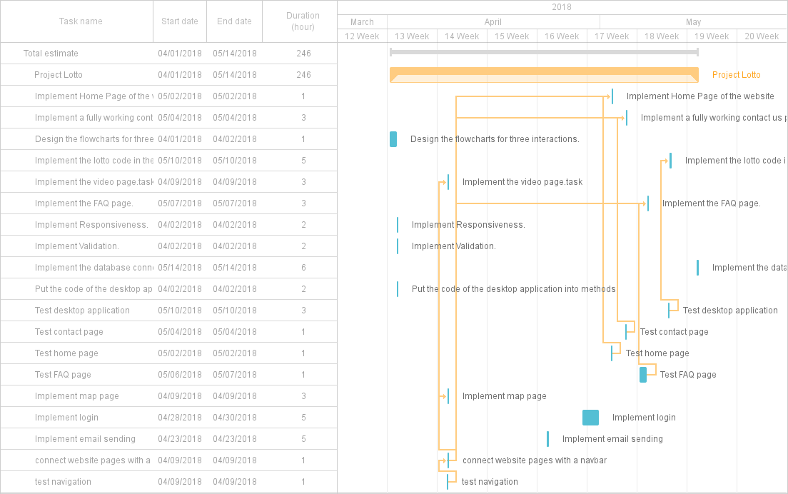

8) If your solution includes a database: a) For 3 interactions in your application, create a flowchart or a UML Activity diagram showing the workflow/activity-flow in detail. Complete diagrams, abiding with correct notations are required. (6 marks)

1. **Enter Lotto Numbers**
2. **Contact Us**
3. **Login**

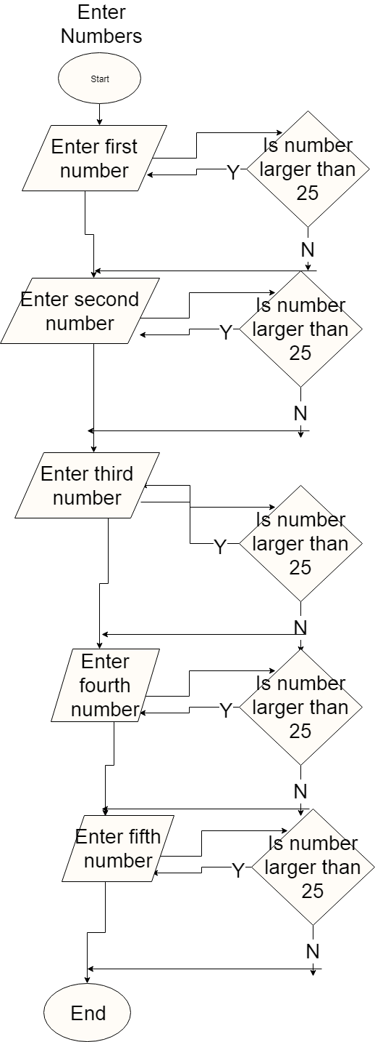

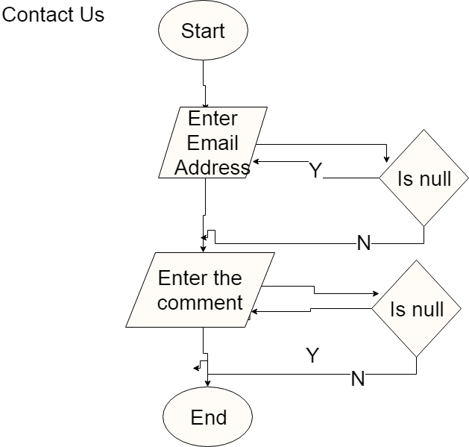

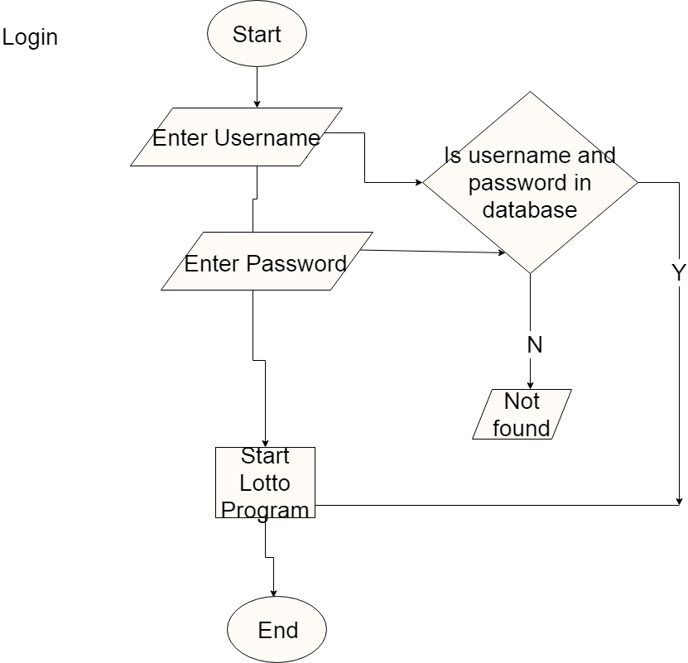

b) Create an ERD showing the design of your database. Make sure your database is well-designed and normalised. (4 marks) If your solution does not include a database:

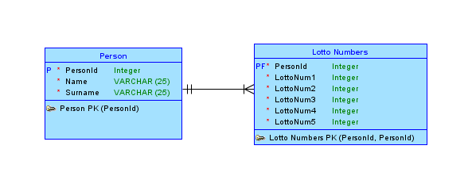

a) For 5 interactions in your application, create a flowchart or a UML Activity diagram showing the workflow/activity-flow in detail. Complete diagrams, abiding with correct notations are required. (10 marks)

9) Explain 5 specific considerations that you took during the project. This can refer to the UI of the web application, the UI of the mobile/desktop application, or the logo/poster (1 mark each).

Simplicity

The web application cannot have extra features which are not relevant to the website. If this were to occur it could ruin the user’s experience and will lead to a more attractive application.

The Colours

The web application must have colours and themes that go with each other. If for example the user sees a lot of dark colours in the application, it could result in the visuals (ex. Text) appearing less.

Consistency

The pages on the web application must have a consistent layout. If there is no consistency between each page, then the web application will not appear whole since each page’s layout is different from one another.

The Typography

Certain text have more importance than others thus it is important to show them in a way that suits their importance. The higher the importance the bigger and bolder the text will become.

Spacing

Certain content must be separated from other content. This is because it would not be neat and wise to make certain texts or images very close to each other (ex. The navigation links need to be separated so that the user would have an easier time pressing the links).

10) Write down the link to the repository you will be using for this project. You are expected to assign your lecturer as an admin on this repository.

<https://github.com/Flukemine/Project.git>